**Web Programming – CS4032**

**Assignment 03**

**Name: Razeen Shahid & Ahmad Rayyan**

**Roll Number: 21F-9224 & 21F-9266**

**Section: BSCS-6B**

**Course Instructor: Muhammad Hannan Farooq**

TASK 01:

HTML:

<!DOCTYPE html>

<html lang="en">

<head>

  <title>Bootstrap Example Task 01</title>

  <meta charset="utf-8">

  <meta name="viewport" content="width=device-width, initial-scale=1">

  <link href="https://cdn.jsdelivr.net/npm/bootstrap@5.3.2/dist/css/bootstrap.min.css" rel="stylesheet">

</head>

<body>

  <div class="container mt-3">

    <h1>Task 01</h1>

    <br>

    <table class="table">

      <tbody>

        <tr class="table-success">

          <td class="text-success">Feel good about Bootstrap</td>

        </tr>

        <tr class="table-info">

          <td class="text-info">Feel informed about Bootstrap</td>

        </tr>

        <tr class="table-warning">

          <td class="text-warning">Feel warned about Bootstrap</td>

        </tr>

        <tr class="table-warning">

          <td class="text-warning">Maybe I should read the docs...</td>

        </tr>

        <tr class="table-danger text-danger">

          <td class=" text-danger">Danger Zone</td>

        </tr>

        <tr class="table-danger">

          <td class=" text-danger">I really should read the docs...</td>

        </tr>

      </tbody>

    </table>

  </div>

</body>

</html>

OUTPUTS:



TASK 02:

HTML:

<!DOCTYPE html>

<html lang="en">

<head>

    <meta charset="UTF-8">

    <meta name="viewport" content="width=device-width, initial-scale=1.0">

    <title>Bootstrap Example Task 02</title>

    <link href="https://cdn.jsdelivr.net/npm/bootstrap@5.3.2/dist/css/bootstrap.min.css" rel="stylesheet">

</head>

<body>

    <div class="container mt-3 text-center">

        <h2>Welcome to our website!</h2>

        <h4>Look at this button! Wow, let's click on it!</h4>

        <div class="d-grid">

            <button type="button" class="btn btn-primary btn-block">Learn more</button>

        </div>

    </div>

    <br>

    <div class="container mt-3">

        <h2>Let's look at some random pictures!<span> from http://lorempixel.com</span></h2>

        <br>

        <div class="row">

            <div class="col-md-4">

                <div class="card">

                    <img class="card-img-top" src="picture1.jpg" alt="Card image cap">

                    <div class="card-body">

                        <p class="card-text">Lorem ipsum dolor sit amet, consectetur adipiscing elit, sed do eiusmod

                            tempor incididunt ut labore et dolore magna aliqua. Ut enim ad minim veniam, quis nostrud

                            exercitation ullamco laboris nisi ut aliquip ex ea commodo consequat. Duis aute irure dolor

                            in reprehenderit in voluptate velit esse cillum dolore eu fugiat nulla pariatur. Excepteur

                            sint occaecat cupidatat non proident, sunt in culpa qui officia deserunt mollit anim id est

                            laborum.</p>

                    </div>

                </div>

            </div>

            <div class="col-md-4">

                <div class="card">

                    <img class="card-img-top" src="picture1.jpg" alt="Card image cap">

                    <div class="card-body">

                        <p class="card-text">Lorem ipsum dolor sit amet, consectetur adipiscing elit, sed do eiusmod

                            tempor incididunt ut labore et dolore magna aliqua. Ut enim ad minim veniam, quis nostrud

                            exercitation ullamco laboris nisi ut aliquip ex ea commodo consequat. Duis aute irure dolor

                            in reprehenderit in voluptate velit esse cillum dolore eu fugiat nulla pariatur. Excepteur

                            sint occaecat cupidatat non proident, sunt in culpa qui officia deserunt mollit anim id est

                            laborum.</p>

                    </div>

                </div>

            </div>

            <div class="col-md-4">

                <div class="card">

                    <img class="card-img-top" src="picture1.jpg" alt="Card image cap">

                    <p class="card-text">Lorem ipsum dolor sit amet, consectetur adipiscing elit, sed do eiusmod tempor

                        incididunt ut labore et dolore magna aliqua. Ut enim ad minim veniam, quis nostrud exercitation

                        ullamco laboris nisi ut aliquip ex ea commodo consequat. Duis aute irure dolor in reprehenderit

                        in voluptate velit esse cillum dolore eu fugiat nulla pariatur. Excepteur sint occaecat

                        cupidatat non proident, sunt in culpa qui officia deserunt mollit anim id est laborum.</p>

                </div>

            </div>

        </div>

    </div>

    </div>

    <br><br>

    <div class="container mt-3">

        <table class="table">

            <tbody>

                <tr class="table-success">

                    <td class="text-success text-center">Thanks for Visting!</td>

                </tr>

    </div>

</body>

</html>

OUTPUTS:

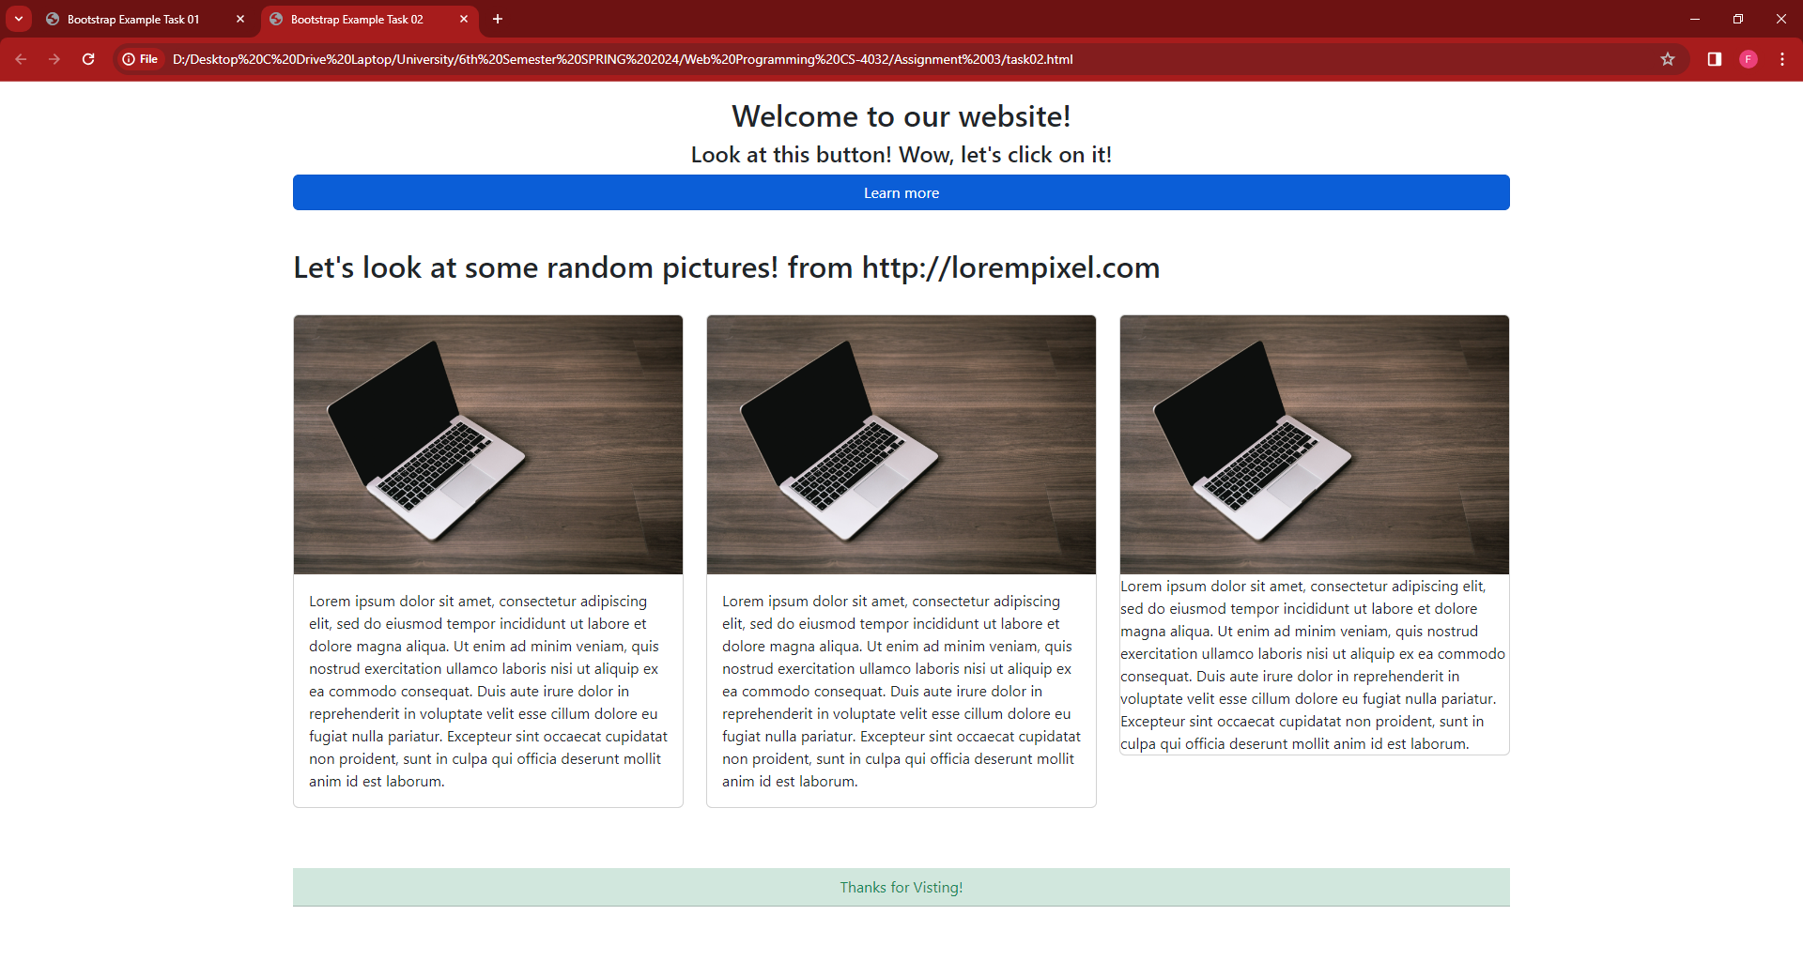

TASK 03:

HTML:

